Monday, July 24th
5:30 pm Lite Supper before Outdoor Worship Service
*Free Will Offering
6:00 pm Outdoor Worship Service @ Nester Park
*sponsored by Olivia Area Churches
BRING LAWN CHAIRS AND/OR BLANKETS FOR YOUR COMFORT

Tuesday, July 25th
Hide & Seek Corn Token Hunt – first clue at 7:45 am on
Big Country 100.1 FM
All clues posted at the Renville Co. Register Office.
Winner receives $100 in Corn Capital Cash!
Claim prize at Olivia City Hall, if after-hours, leave message 523-2361
RCAC Splash 'N' Dash Kid's Triathlon - Grades K-6
4:00 pm Registration begins, 4:45 pm Meeting, 5:00 pm Start time
email to kidstri@rcac.com or go to www.rcacorcas.com
Registration deadline 7/12/2017

Wednesday, July 26th
6:00 pm Par 3 Golf Tournament @ Olivia Golf Club
6:00 pm Outdoor Community Bingo @
Olivia Rehabilitation & Healthcare Center
(formally Golden Living Center of Olivia)
*sponsored by Olivia Rehab & Healthcare Center and Olivia Ambulance.
Come Play Rain or Shine!
Children may play if accompanied by a parent or guardian.

Thursday, July 27th
12 pm – 8 pm Used Book Sale @ Olivia Library
2-4 pm Pie & Ice Cream Social @ Fairview Place
5 – 8 pm Grilled Pork Chops & Sweet Corn @ Olivia Legion Post 186
5 – 8 pm Family Fun Night Kiddie Carnival @ Dirks Parks – N. 7th St.
Tug-of-War Matchup, Fire Truck Tours, Spraying Fire Hose
*sponsored by Olivia Fire Department
Petting Zoo, Inflatables, Kiddie Games & Activities
*sponsored by Olivia Ambulance Service
Petting Zoo sponsored by Olivia Ambulance
Pony Rides sponsored by Olivia Ambulance
*Concessions @ Dirks Park by Olivia Cub Scout Pack 313 + Plus more!
CCT providing shuttles to Dirks Park 5 - 8 pm
Running 15-minute schedule from City Hall
9pm - close IV Play at Brly's Den
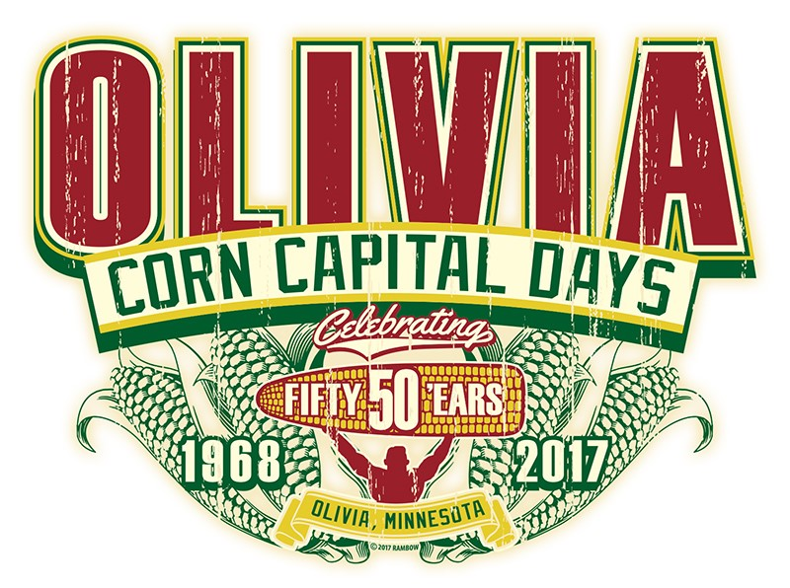
Friday, July 28th
8 am - 2 pm Downtown Crazy Days @ Olivia Merchants
9 am - 2 pm Young Entrepreneur Day (w/ Crazy Days)
10 am – 5 pm Used Book Sale @ Olivia Public Library
11 am Zoomobile @ Olivia Public Library
11 am - 1 pm Live Music Downtown @ Dowling Park
11 am - 1 pm Downtown food options available.
12 pm – 4 pm Root Beer Floats by BOLD FFA @ Upper Midwest Mgmt. (across from Max's Grill)
*Proceeds go to BOLD High School FFA program.
2-3 pm Free Youth Paint "Pond Park" at Chamber Office by
Studio 125 & Olivia Chamber
Paint registration for ages 8-18 from 8 am -1 pm at Dowling Park –
Class size limit: 20
4:30 pm – 7 pm Kid’s Fair @ Faith United Methodist Church (9th St.)
5 pm – 7 pm Ice Cream Social @ Faith United Methodist Church
5 pm REGISTRATION FOR CHILDREN’S PEDAL PULL
5:30 pm Children’s Pedal Pull @ F&M Bank parking lot
5:00 pm – 8 pm Cindy's Nachos @ American Legion Post 186
7:00 pm - 12:00 am FREE Downtown Street Dance
DJ 7-9 pm / Fabulous Armadillos 9-12
Fireworks approx. 10:15
Beer Gardens served by American Legion Post 186 (7pm - 12 am)
NASCAR Simulator
Food Vendors available @ Street Dance
9 – close DJ All Mixed Up @ Brly’s Den

Saturday, July 29th
7 am – Noon Legion Breakfast @ Olivia American Legion Post 186
w/ Bloody Mary Bar at 9:00 am (Legion)
7:30 am – 8 am Health Choice Corn Capital Run @ S. Nester Park
8 - Noon Jon Wogen Memorial Youth Fishing Event
Two Flights -Ages 5-10, 8-10:00 am / Ages 11-16, 10-Noon
9 am – 12:30 pm Olivia Car & Bike Show @ St. Al’s (11th St. S. & Park Ave)
NASCAR Simulator
*Please bring a food shelf item for donation.
9 am – 12 pm Used Book Sale @ Olivia Public Library
9 am – 4 pm Kiwanis Arts & Crafts in the Park @ Nester Park S. 9th St.
10:00 am Kiddie Parade Line-up south of ACTS
10:30 am Corn Capital Days Kiddie Parade
THEME: "Golden Ear of Corn"
*Starts @ ACTS and route around S. Nester Park
11 am – Noon Corn Toss with BOLD NHS @ Nester Park
11 am – 1 pm Corn Feed featuring Green Leaf Sweet Corn &
ADM Edible Beans @ Nester Park
*Free Will Donation
11 am – 2 pm Drunk Goggles Obstacle Course by OPD @ Nester Park
11:30 am – 1:30 pm Music in the Park w/ Blue Ox Jazz Babies
Noon – 1 pm Cornlympics! with BOLD FFA @ Nester Park
3 pm Corn Capital Days Grand Parade
2017 - 50th Anniversary Grand Marshals
Mary Ellen Rauenhorst and John & Dee Wannigman
*Following parade – Hot Turkey, Beans & Potato Salad
*sponsored by American Legion & Auxiliary
5:30 - 8:30 pm The Wendinger Band @ Olivia Legion Post 186
4-6pm Free Hot Dogs, limit 2 ea. (while supplies last) @ Brly’s Den
6 pm Women’s 3-Person Corn Cap Scramble @ Olivia Golf Club
9 pm – close Lost Highway (outside) @ Max’s Bar & Grill
9 pm – close 4 bands/4 different music types (no cover) @ Brly’s Den
RI / Moonlight / Down Range / Sapiosexual

Sunday, July 30th
8:00 am -12 pm Lion’s Club Fly-In Breakfast
*Pancakes, Eggs & Sausage @ Olivia Airport
9 am Volleyball Tournament @ Sunrise Park
10:00 BOLD Area Youth Sports Bean Bag Tourney @ Sunrise Park
$5 per person - 2 divisions /0-18 and Adult
10 am Rem/Rabi Memorial Golf Tournament @ Olivia Golf Club
12 pm Bean Bag Tourney & 6 Team Volleyball Tourney @ Brly’s Den

Celebrating 50 Years in the Corn Capital!
www.corncapitaldays.com
@CornCapitalDays

